library("tidyverse")

## ── Attaching packages ─────────────────────────────────────────────────────── tidyverse 1.3.0 ──

## ✓ ggplot2 3.2.1 ✓ purrr 0.3.3  
## ✓ tibble 2.1.3 ✓ dplyr 0.8.4  
## ✓ tidyr 1.0.2 ✓ stringr 1.4.0  
## ✓ readr 1.3.1 ✓ forcats 0.4.0

## ── Conflicts ────────────────────────────────────────────────────────── tidyverse_conflicts() ──  
## x dplyr::filter() masks stats::filter()  
## x dplyr::lag() masks stats::lag()

library("VIM")

## Loading required package: colorspace

## Loading required package: grid

## Loading required package: data.table

##   
## Attaching package: 'data.table'

## The following objects are masked from 'package:dplyr':  
##   
## between, first, last

## The following object is masked from 'package:purrr':  
##   
## transpose

## VIM is ready to use.   
## Since version 4.0.0 the GUI is in its own package VIMGUI.  
##   
## Please use the package to use the new (and old) GUI.

## Suggestions and bug-reports can be submitted at: https://github.com/alexkowa/VIM/issues

##   
## Attaching package: 'VIM'

## The following object is masked from 'package:datasets':  
##   
## sleep

library("mice")

## Loading required package: lattice

## Registered S3 methods overwritten by 'lme4':  
## method from  
## cooks.distance.influence.merMod car   
## influence.merMod car   
## dfbeta.influence.merMod car   
## dfbetas.influence.merMod car

##   
## Attaching package: 'mice'

## The following object is masked from 'package:tidyr':  
##   
## complete

## The following objects are masked from 'package:base':  
##   
## cbind, rbind

grades = read_csv("class-grades.csv")

## Parsed with column specification:  
## cols(  
## Prefix = col_double(),  
## Assignment = col_double(),  
## Tutorial = col_double(),  
## Midterm = col_double(),  
## TakeHome = col_double(),  
## Final = col_double()  
## )

str(grades)

## Classes 'spec_tbl_df', 'tbl_df', 'tbl' and 'data.frame': 99 obs. of 6 variables:  
## $ Prefix : num 5 8 8 7 8 7 8 7 8 7 ...  
## $ Assignment: num 57.1 95 83.7 81.2 91.3 ...  
## $ Tutorial : num 34.1 105.5 83.2 96.1 93.6 ...  
## $ Midterm : num 64.4 67.5 30 49.4 95 ...  
## $ TakeHome : num 51.5 99.1 63.1 105.9 107.4 ...  
## $ Final : num 52.5 68.3 48.9 80.6 73.9 ...  
## - attr(*, "spec")=  
## .. cols(  
## .. Prefix = col_double(),  
## .. Assignment = col_double(),  
## .. Tutorial = col_double(),  
## .. Midterm = col_double(),  
## .. TakeHome = col_double(),  
## .. Final = col_double()  
## .. )

Task 1 - There are about 11 NA’s and in the variables: Midterm, TakeHome, Tutorial and Final.

vim_plot = aggr(grades, numbers = TRUE, prop = c(TRUE,FALSE), cex.axis = 0.7)

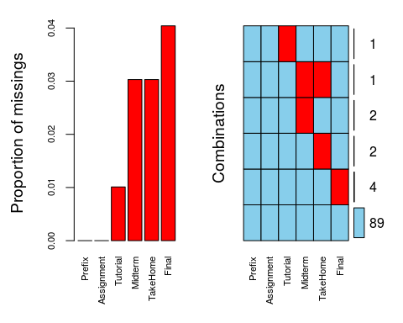

Task 2 - There appears to be systematic missingness with students missing multiple pieces of data.

grades2 = grades %>% drop_na()  
str(grades2)

## Classes 'tbl_df', 'tbl' and 'data.frame': 89 obs. of 6 variables:  
## $ Prefix : num 5 8 8 7 8 7 8 8 7 7 ...  
## $ Assignment: num 57.1 95 83.7 81.2 91.3 ...  
## $ Tutorial : num 34.1 105.5 83.2 96.1 93.6 ...  
## $ Midterm : num 64.4 67.5 30 49.4 95 ...  
## $ TakeHome : num 51.5 99.1 63.1 105.9 107.4 ...  
## $ Final : num 52.5 68.3 48.9 80.6 73.9 ...

Task 3 - 89 rows remain in this new data set.

grades3 = grades %>% select(Tutorial, Midterm, TakeHome, Final)

Task 4 - 99 rows remain in this new data set.

Task 5 - row-wise deletion seems preferable for this dataset. The data is in multiple columns so deleting the columns is not preferable as it deletes data we may need. The row-wise deleted the rows in which the NA information was in.

grades_imp = mice(grades, m=1, method = "pmm", seed = 12345)

##   
## iter imp variable  
## 1 1 Tutorial Midterm TakeHome Final  
## 2 1 Tutorial Midterm TakeHome Final  
## 3 1 Tutorial Midterm TakeHome Final  
## 4 1 Tutorial Midterm TakeHome Final  
## 5 1 Tutorial Midterm TakeHome Final

summary(grades_imp)

## Class: mids  
## Number of multiple imputations: 1   
## Imputation methods:  
## Prefix Assignment Tutorial Midterm TakeHome Final   
## "" "" "pmm" "pmm" "pmm" "pmm"   
## PredictorMatrix:  
## Prefix Assignment Tutorial Midterm TakeHome Final  
## Prefix 0 1 1 1 1 1  
## Assignment 1 0 1 1 1 1  
## Tutorial 1 1 0 1 1 1  
## Midterm 1 1 1 0 1 1  
## TakeHome 1 1 1 1 0 1  
## Final 1 1 1 1 1 0

densityplot(grades_imp)

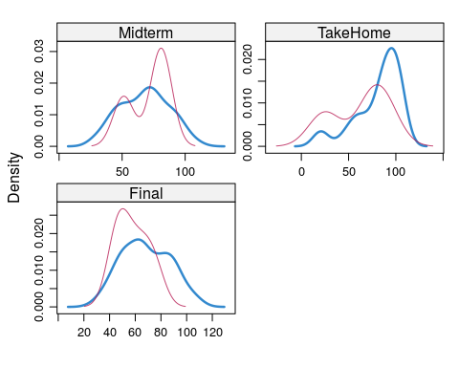

grades_complete = complete(grades_imp)  
summary(grades_complete)

## Prefix Assignment Tutorial Midterm   
## Min. :4.000 Min. : 28.14 Min. : 34.09 Min. : 28.12   
## 1st Qu.:7.000 1st Qu.: 80.88 1st Qu.: 84.69 1st Qu.: 52.50   
## Median :8.000 Median : 89.94 Median : 93.10 Median : 69.38   
## Mean :7.313 Mean : 85.49 Mean : 89.76 Mean : 67.80   
## 3rd Qu.:8.000 3rd Qu.: 95.00 3rd Qu.:100.55 3rd Qu.: 81.88   
## Max. :8.000 Max. :100.83 Max. :112.58 Max. :110.00   
## TakeHome Final   
## Min. : 16.91 Min. : 28.06   
## 1st Qu.: 67.96 1st Qu.: 52.09   
## Median : 87.96 Median : 65.56   
## Mean : 80.54 Mean : 67.81   
## 3rd Qu.: 98.42 3rd Qu.: 83.19   
## Max. :108.89 Max. :108.89

Task 7 - Potential issues that could be encountered when working with missing data is eliminating rows and columns that have data that is necessary for the project we are working on. There are three things to use when dealing with missing data: column-wise deletion, row-wise deletion and imputation. With column-wise deletion you run the risk of deleting columns that have NA values that are imperative to the data and project you are working on. With row-wise deletion you run the risk of deleting the rows that have NA data and that could pose a problem with deleting the rows that could be important information. Imputation is only good with numerical numbers, but with imputation it would not be advisable to use with categorial variables because it’s main method is predictive mean matching which uses the values around it to determine a value to replace NA with.